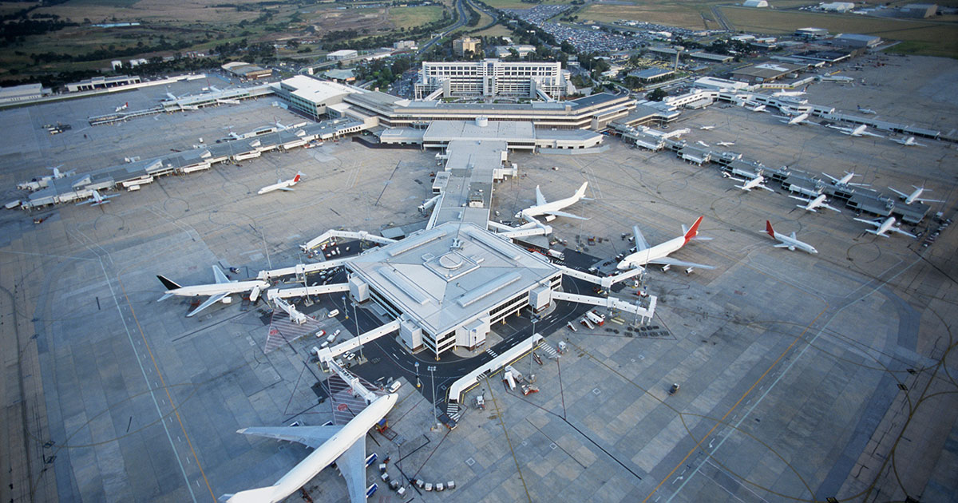

Airport Management System

Database Design Project

Gunjan Tomer (gxt160930)

Koulick Sankar Paul(ksp160330)

Abhishek Jagwani(alj160130)

# Requirements

An airport management system is a complex network of different facets of the service industry working together. Rather than just the management of flights and passengers, it encompasses various other domains. This project is an attempt to weave together all such different aspects of an airport’s operations and provide a qualified but well-researched insight into its intricate working while abstracting over the low-level details like passenger handling, in-flight practices and other external branch-offs from an airport’s day-to-day dealings.

The main entities in our system along with a brief description of their operations follows below. Also included are our assumptions and logical decisions to with regards to the behavior of certain entities and their interactions with each other in an attempt to emulate real world scenarios as much as possible.

* **Airline:**

The airport has a number of airline companies who operate their flights to and from the place and avail the airport’s services when required. Each Airline operator is assigned a unique carrier ID and can operate one or more flights from the airport.

* **Flight:**

There can be multiple flights between different cities which either depart from our airport or have it as a destination. Each flight is operated by a specific Airline carrier, has a specific make, seat capacity and also the days in a week it operates. Each flight is identified by a unique flight number.

* **Flight_instance:**

A flight has a defined origin and destination and an Airline company may operate multiple instances of the flight between two cities in a single day. Each such instance on a particular date has estimated arrival and departure times, along with a check-in time and seat availability count for outbound flights from the airport. Each flight instance is identified by a unique flight code reflecting the flight’s number and the date on which it operates.

* **ATC:**

The Air Traffic Control system at the airport consists of multiple towers which coordinate flights and provide regular updates on their status which in turn are used to modify the flight schedule attributes for the flight instance. Each ATC tower has a unique Tower ID.

* **Staff:**

The airport employs staff to work in different areas like maintenance, field work, security, ATC and vehicle operation. Each employee with a unique Staff ID is categorized under a particular department, has defined working hours and operates one or more vehicles if the job entails. The ATC is usually operated my more than one person from the staff.

* **Vehicle:**

The airport uses a number of vehicles which are kept track of using a Vehicle ID. They can be of different types ranging from plane-tugs, refuelers and baggage carts to buses ferrying passengers to their flights. Each vehicle can only be operated by an authorized staff member. There may be a number of vehicles of the same type and a person authorized to operate any one of those.

* **Vendor:**

The airport has some locations where different companies can set up shop like the Airport Mall, lounge area, the check-in are etc. The vendors who are allocated space inside the airport have defined hours when they are open, a location in the airport and the type of things they sell as their attributes along with a unique Vendor ID.

* **Resource:**

The airport has a number of resources which make flight operations possible. Each flight instance has specific resources allocated to it by the airport to ensure a smooth process. Some resources we included are runways for flights, check-in desks for different carriers apart from departure gates, air bridges and baggage claim areas. A flight may use one or more resources depending on its requirement at the time.

* **Invoice:**

Invoices are the lifeblood of an airport’s operations. The airline operators regularly pay the operator for using its resources and the vendors who run shops inside the airport pay rent. Each transaction between these parties is logged with a distinct invoice number and the amount involved. Invoices are generated by each flight instance and each vendor separately. Although, a vendor may generate multiple invoices if operates more than one shop in the airport. e.g. a coffee shop near the check-in and a diner in the airport lounge.

# Entity Relationship Diagram

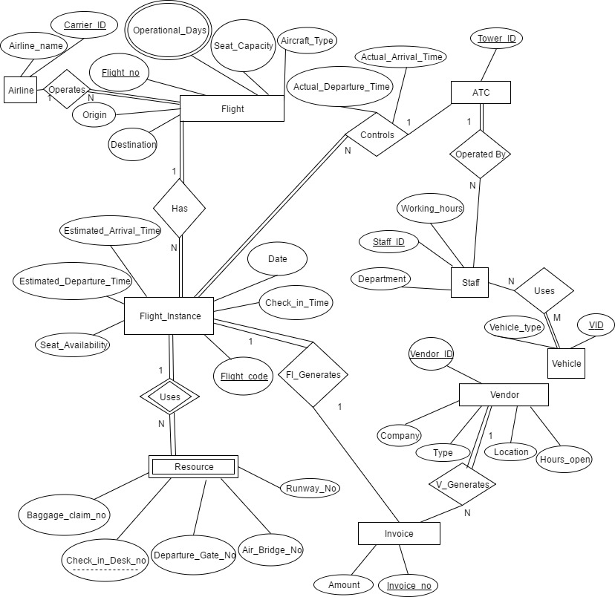

# Relational Model